Software Requirements Specification
Software Engineering
22 August 2020

IVENTORY & BILLING SYSTEM

Software Requirements Specification

MUHAMMAD FURQAN ANSARI
Project Leader

Ayesha Ali
Shaista
Haris
Project Members

Prepared for
Software Engineering
Instructor: Sir Mansoor Ibrahim/Miss Ghazala
Summer 2020

Table of Contents
1. Introduction 1
1.1 Purpose 1
1.2 Scope 1
1.3 Overview 1
2. General Description 1
2.1 Product Perspective 1
2.2 Product Functions 2
2.3 User Characteristics 2
2.4 General Constraints 2
3 External Interface Requirements 2
3.1 User Interfaces 2
3.2 Hardware Interfaces 2
3.3 Software Interfaces 2
3.4 Communications Interfaces 2
4. Functional Requirements 3
4.1 Searching of data……………………………………………………………………………………………...3
4.2 Updating of data……………………………………………………………………………………………...3
4.3 Deleting of data ………………………………………………………………………………………......…..3
4.4 Adding of data………………………………………………………………………………………………..4
4.5 Credit Receipt ………………………………………………………………………………………………..4

5. Non-Functional Requirements 4
5.1 Performance 4
5.2 Reliability 4
5.3 Security 5
5.4 Maintainability 5
5.5 Portability 5
6. Use Case…………………………………………………………………………………………………………….5
6.1 Sub Use case 1………………………………………………………………………………………………6
6.1 Sub Use case 2………………………………………………………………………………………………7
6.1 Sub Use case 3………………………………………………………………………………………………9
6.1 Sub Use case 4..……………………………………………………………………………………………11

7. Analysis Models
7.1 ERD 12

- Introduction
This system will help a medical store owner to easily access its data storage and maintain the inventory quite easily. We will be developing an inventory system as well as the billing system. In inventory system the owner or the admin can check the status, the amount, the price, the availability etc. of medicines in the store. While also he can print a billing statement for the customer.

1.1 Purpose
This system can be modified to be used in multiple areas of working. We can make few amendments and it can be used at a general store, at a hospital dispensary etc. Plus this will lessen the burden of the owner by doing all the manual work digitally.

1.2 Scope
This project can be further modified in order to become a complete inventory system and also with a few alterations we can also make this into a hospital management system. This software is being used in multiple places in today’s world.
This system can provide a lot of help to the owner. Instead of completing manuscripts of the medicines available and doing all the calculations by mind, this system can provide all the help.

1.3 Overview
Furthermore this report contains all the information related to the requirement phase of the project, all the functional & non-functional requirements, the ERD diagram, Use case diagrams, Data Flow diagrams & the prototype of how the user interface will look like.

2. General Description
General factor that can affect the quality of this project is the time span allotted to us. Apart from that, there is no such risk, apart from anything collapses at the last hour. We will be taking feedback from the client from time to time, so that there are no last minute issues and we can make project as close to the client’s requirement at possible.

2.1 Product Perspective
This product looking from the user’s point of view is the need of the time. As everything is being transferred to be less manual and more technology based. This system will be helpful for user, as it will lessen the manual work and will be helpful in the management part. A lot of shopping stores are using such system at their outlets, to fasten their working rate.

2.2 Product Functions
This product will perform all the inventory function, such as adding data into the database, deleting data, updating already provided information, searching the data and finally developing a receipt at the checkout and printing it.

2.3 User Characteristics
The user will be provided with a id and password, and only designated users will be allowed to access the system and use it. Apart from the admins, none shall be allowed to use the system. Changes in the admins will firstly be required to be added into the database, only then new users will be able to access the system. Any other aspects of the system will not be affected by the users.

2.4 General Constraints
There are no as such general constraints for this project, except if any causality occurs at the last moment.

3 External Interface Requirements

Will use the Multiple Software for developing this product may change according to user feedback.

3.1 User Interfaces
Will use Bootstrap and other libraries to develop the UI. We will create an interactive use interface which be easy for the user to use and attractive.
Requirements in order to create effective user interface will be efficiency in languages used in designing GUI.

3.2 Hardware Interfaces
Product will generate the Receipt according to provided data and Receipt Machine will print it.
A printing machine will be used in order to print out the receipt if needed.

3.3 Software Interfaces
We will use visual studio for developing the software. Bootstrap and other JavaScript plugins for the functionality. Local DB for managing the data of the software

3.4 Communications Interfaces
The product will use Web browser, network communication and electronic forms.

4 Functional Requirements
Notable Functional requirement of this system can be a working database in order to maintain and function the inventory system. There should be no database anomalies. All the database functions like insertion of data, deletion of data, updating of data, searching of data, adding of data into the cart and then providing a checkout bill.

4.1 Searching of Data:
4.1.1 Introduction:
User will be allowed to search the desired item through the data.

4.1.2 Inputs:
User will input code or ID of the medicine.

4.1.3 Processing:
Through database commands, using that input code/ID, system will search that specific item.

4.1.4 Outputs:
All the desired information related to that specific item will be given as output.

4.2 Updating of Data
4.2.1 Introduction
User will be allowed to update the information in the data.

4.2.2 Inputs
User will input any key value in order to search for that specific data

4.2.3 Processing
The system will search the database using the input key, and bring out the information related to that item. Then the user can update it and save it.

4.2.4 Outputs
Information related to that item will be output and then updated information will be saved.

4.3 Deleting of Data
4.3.1 Introduction
Admin will be allowed to delete unwanted information

4.3.2 Inputs
User will input some kind of id/Code no for the medicine and search for it.

4.3.3 Processing
Once the information shows up, there will also be an option for deleting the information. On clicking that button the information will be deleted.

4.3.4 Output
As the output that information will be deleted.

4.4 Adding of Data
4.4.1 Introduction
Admin will be allowed to add new information into the system.

4.4.2 Input
There will be an option provided to the user. User will input the information that he wants to add.

4.4.3 Processing
The provided information will be added into the data base

4.4.4 Output
New information will be added into the system.

4.5 Credit Receipt
4.5.1 Introduction
The system will also design a receipt for when making a purchase.

4.5.2 Input
The inputs will be the medicines added into the cart.

4.5.3 Processing
The system will take those inputs and keep saving them into another page which will form the bil receipt.

4.5.4 Output
The output of this feature will be a proper bill receipt with total amount required.

5 Non-Functional Requirements

5.1 Performance
Performance of the system should be up to the mark. Processing of data should not take too much time.

5.2 Reliability
The system will be reliable, would be able to do all the manual work of the client side related to the inventory system.

5.3 Security
The system will be secure. Only allowed users/admins will be allowed to log in into the system. The user ID and password will be checked.

5.4 Maintainability
The process can be maintained/updated from time to time as per the requirement of the client. We can add more features timely.

5.5 Portability
The system will be portable. It can be used at multiple branches.

6 Use Cases
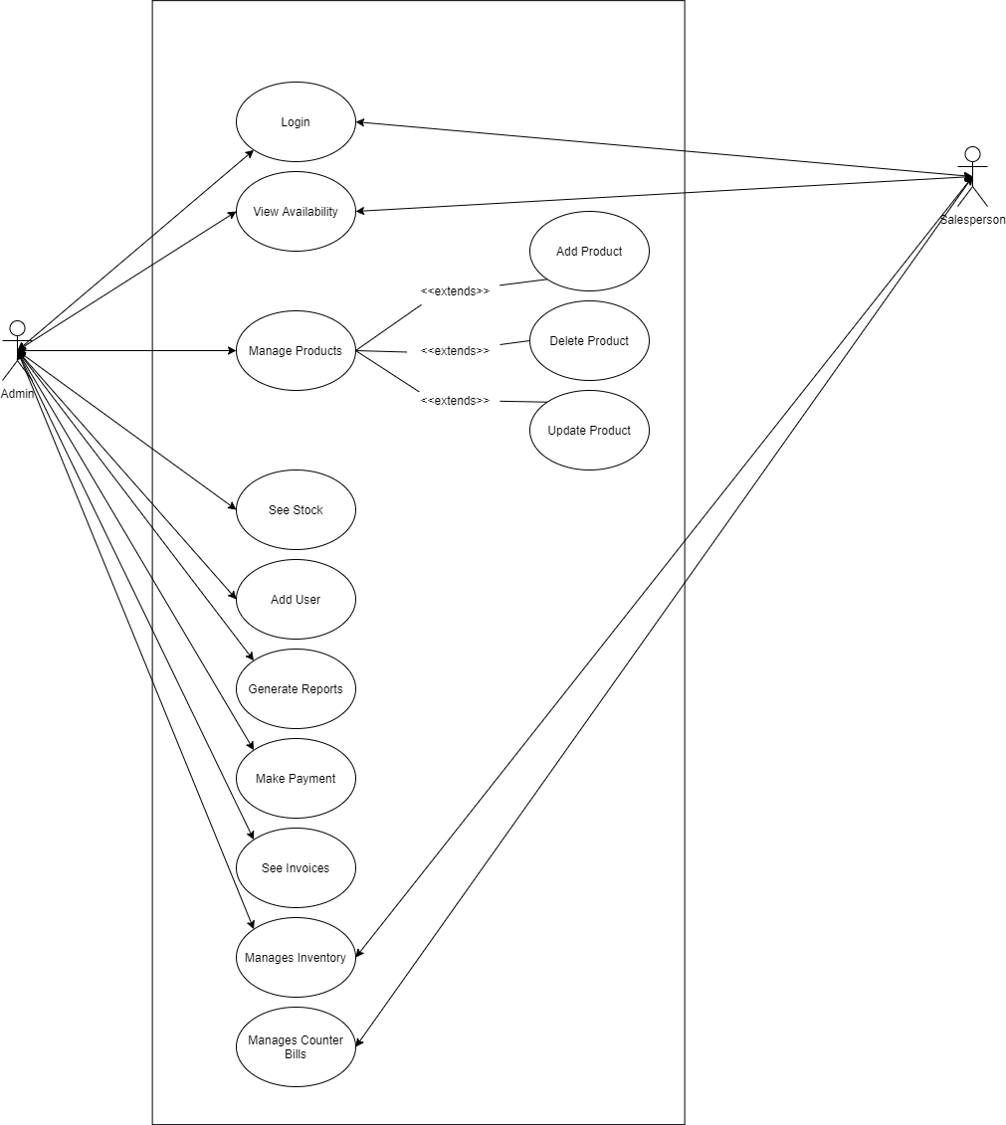

Sub Use Cases

Sub Use Case 1
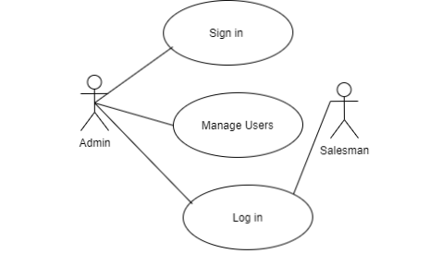
Use Case Name | Log in to the inventory system
Actors Involved | Admin and Salesman
Brief Description | Admin needs to sign in into the system. The admin can manage users and can grant access to any user.
Flow of Events
  Actor Action | System Response
  - Enter email address and password. | 1. System displays the actor (Admin) main page on successful login.
  2. Clicks the submit button. | 2. System displays error message on invalid login.
  - Admin can manage users by giving access into the system. | - The Salesman can now login to the system by entering login credentials.

Sub Use Case 2:
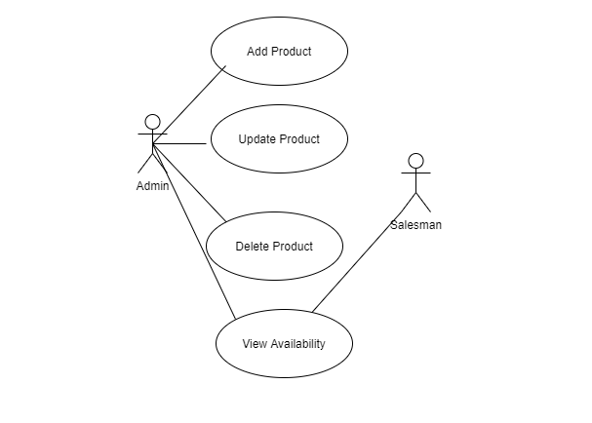
Use Case Name | Updating Products
Actors Involved | Admin and Salesman
Brief Discussion | The Admin can manage products (add, update, delete). Both the actors can check product availability in the inventory in order to maintain and check the stock available or short in quantity.
Flow Of Events
  Actor Action | System Response
  - After logging into the system, the admin adds the product details, and clicks add button. | - The products successfully added into the system.
  - Clicks the update button if required. | - The item has been updated.
  - Clicks delete button if required. | - The item has been deleted.
  - Searching for products. | 4. Checking stock and quantity of products.

Sub Use Case 3:
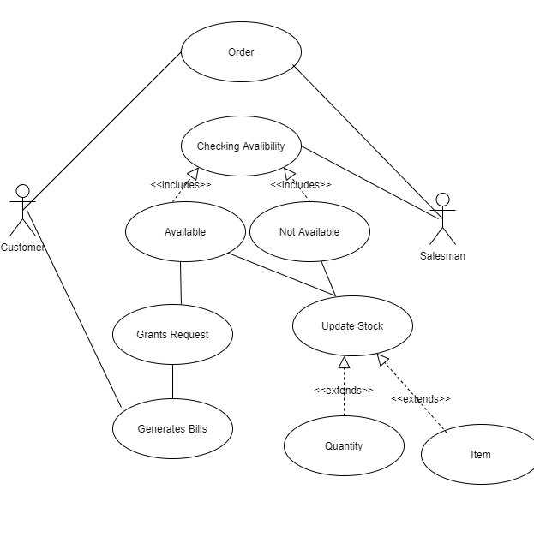
Use Case Name | Managing Orders and updating Stock
Actors Involve | Customer and Salesman
Brief Description | When an order is arrived, the salesman will check the availability of the required product and if available will fulfill the request and generates a bill. In case of both available or not, the system will be updated and will notify on the current state of the stock.
Flow Of Events
  Actors Action | System Response
  - The search option will help finding required product on customer request by name. | 1. Search option will show the required results.
  - After fulfilment of request, clicking generate bill option. | 2. The system will generate bill.

Sub Use Case 4:
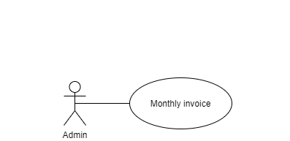

Use Case Name | Generating Reports
Actors Involved | Admin
Brief Description | Admin can generate monthly inventory records.
Flow Of Events
  Actors Action | System Response
  - Clicks the generate report button | - The system will generate monthly report.

7. Analysis Models

7.1 ERD
